**Azure DevOps Documentation**

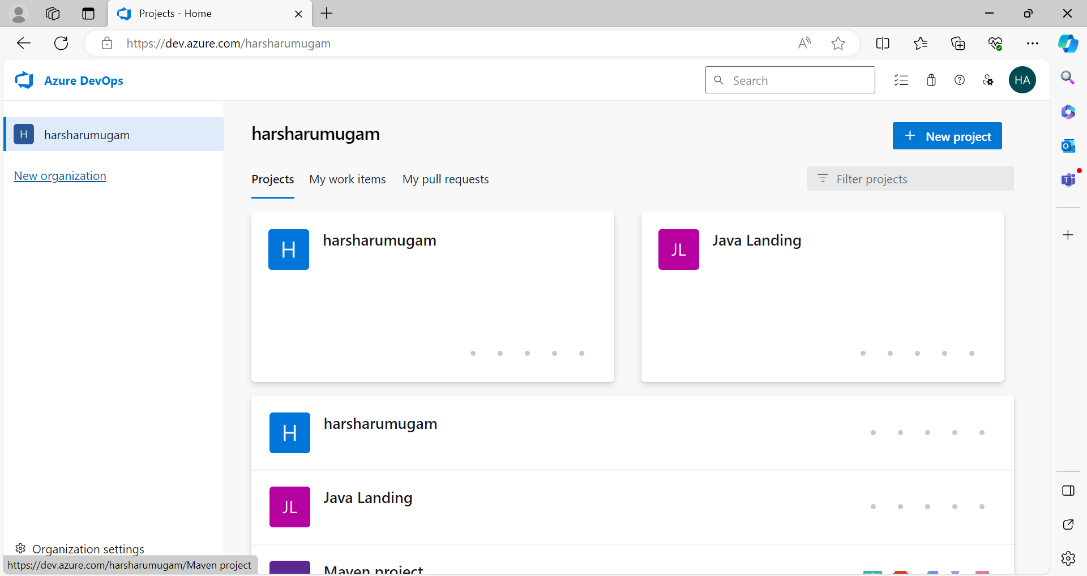

This is my Azure DevOps Home Page where my project is in harsharumugam

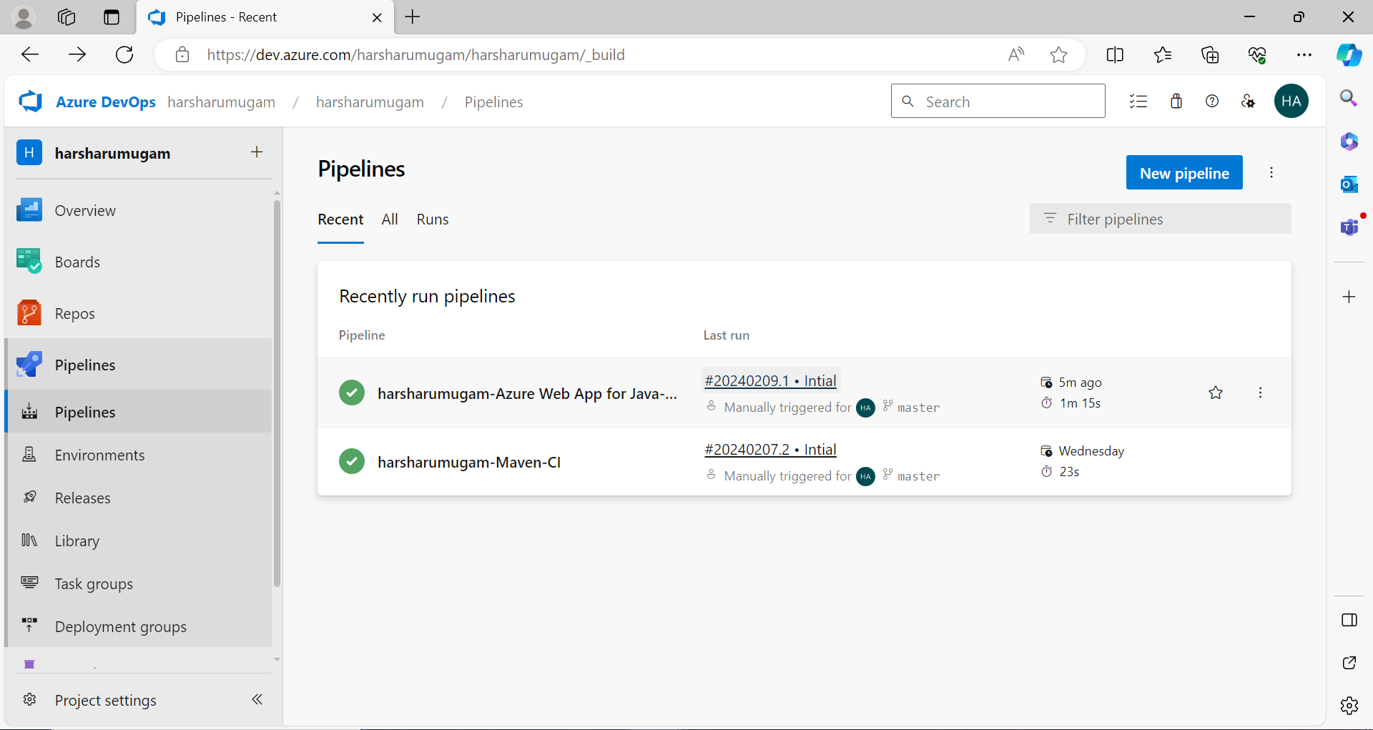

This is my Pipeline which created

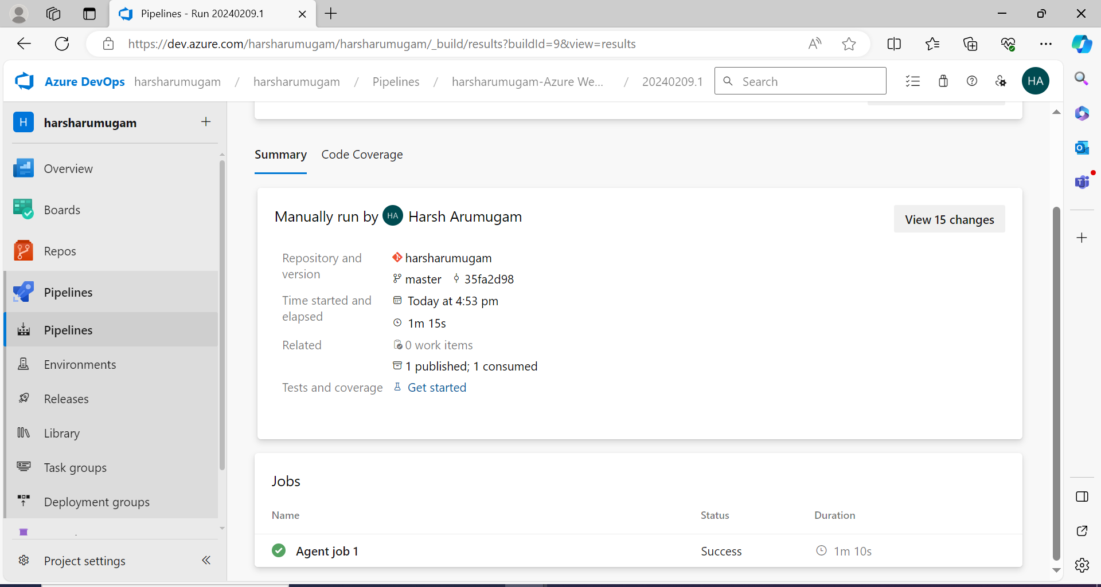

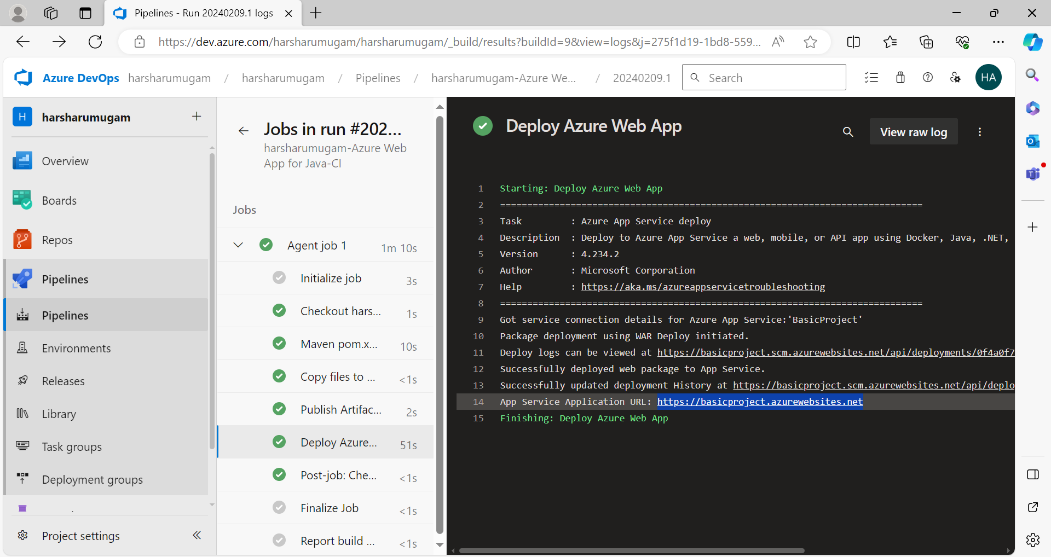

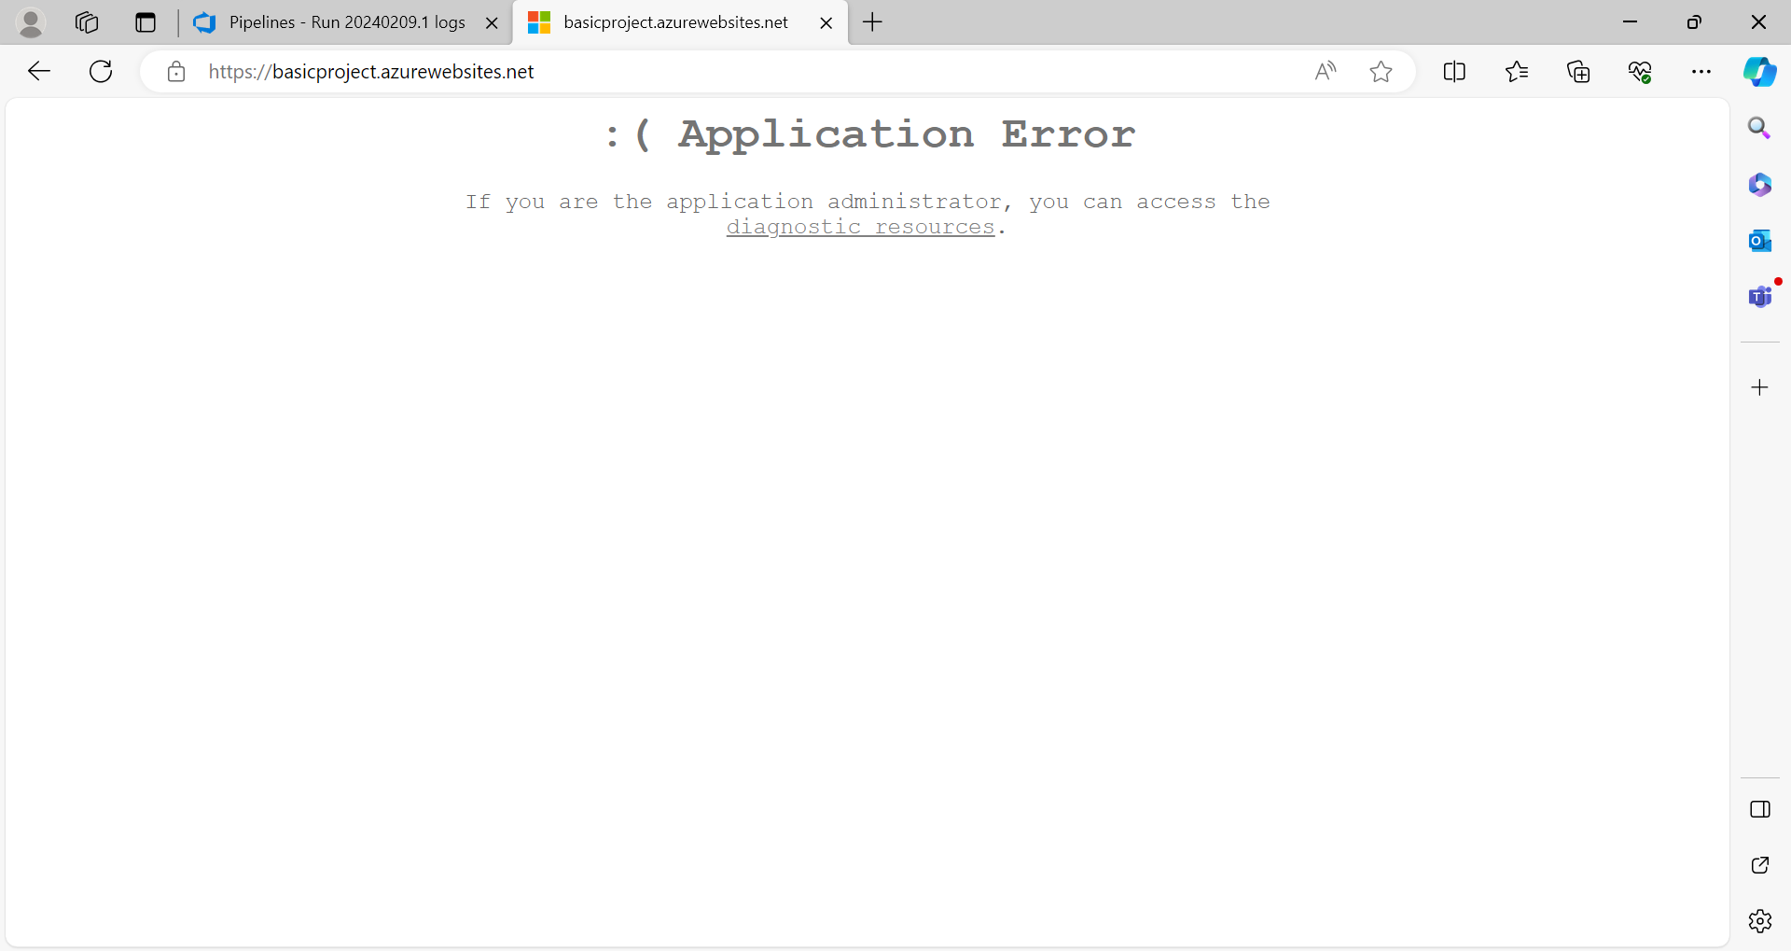

NAME : HARSHAVARTTHAN A

ACE NO : ACE11694